HTU – Al-Hussein Technical University
School of Computing and Informatics

Course Title: Risk Analysis & Systems Testing
Assignment Title: Smart University Online Examination System (SOES) – Risk Analysis Report
Student Name: Ahmad Marwan AlMaghaireh
Student ID: 23110205
Section: 2
Instructor: Rahmeh Ibrahim
Academic Year: 2025–2026
Submission Date: 24/01/2026

Contents
INTRODUCTION 2
Activity 1 – Understanding Risk Analysis and Threat Modelling 3
Question 1 3
Question 2 9
Activity 2 – Threat Modelling for the SOES 16
Question 3 16
Question 4 24
Question 5 25
Question 6 29
Activity 3 – Quantitative Risk Analysis Using the FAIR Methodology 34
Question 7 34
Question 8 37
Question 9 40
Question 10 47
Question 11 49
Question 12 56
Activity 4 – Application of the NIST Cybersecurity Framework (NIST CSF) 58
Question 13 58
Question 14 59
Activity 5 – Jordan National Cybersecurity Framework (JNCSF) and Cybersecurity Regulations 63
Question 15 63
CONCLUSION 67
REFERENCES 67

INTRODUCTION

HTU introduced the Smart University Online Examination System (SOES) to run exams online instead of paper-based exams. SOES is used by students, instructors, and administrators, and it handles very sensitive information like; exam questions, student submissions, grades, and user accounts.
This report analyzes SOES security risks using a clear step-by-step approach. First, it models how data moves in the system (DFD) and identifies threats using STRIDE, then ranks the most serious risks using DREAD. After that, it applies the FAIR methodology to quantify one major risk in terms of frequency and financial impact. Finally, it maps the recommended improvements to cybersecurity best practices using NIST CSF and Jordan’s national cybersecurity framework requirements.

SOES is a cloud-based exam system. Students register, take exams, submit answers, and view results. Instructors upload questions, mark submissions, and publish grades. The system connects to the SIS, a payment service, and an email/SMS gateway for notifications and password resets.
The scenario shows real security concerns: weak authentication (and password sharing), many failed login attempts targeting instructor/admin accounts, suspected access to the question bank before exams, unencrypted communication in some places (HTTP), public APIs without authentication, missing logs/alerts, old accounts staying active, and no tested backup plan—so both exam integrity and availability are at risk.

Activity 1 – Understanding Risk Analysis and Threat Modelling

Question 1

1) Asset
An asset is something that is of value to an organization and its loss, misuse or compromise would adversely impact on the goal of the organization. According to a conventional risk analysis view, the assets are information, systems, processes, and people which have been serving business or operational objectives.

The assets in threat modelling (STRIDE/DREAD) are considered targets that are desired by attackers to be compromised, including databases, accounts, or services. In FAIR, the emphasis moves a step further since the system is not the resource at risk, but rather the information or business value itself, and systems and databases are viewed as containers of that value.

- The most sensitive assets in the SOES case are:

- Question material (academic intellectual property),

- Student test assignments and marks,

- Student and instructor data, personal,

- Teacher and administration accounts.

Among these, the exam question bank is the most valuable asset since breaching of integrity of examinations, fairness, and credibility of the university is direct. Though cloud database is significant, FAIR analysis helps to understand that the actual asset is the privacy and integrity of the exam material that is hosted by the database.

2) Threat

A threat is something that might cause damage to an asset but this is caused by a threat actor (human or system) or an event that could use the vulnerabilities in the system. Threats in threat modelling explain what can go wrong and are usually classified in threat modelling frameworks such as STRIDE.

In a STRIDE view, threat types are categorized based on their impact (e.g., Spoofing, Tampering, Information Disclosure), whereas in FAIR, threats are defined in the form of threat communities, their motives and frequency of harmful activities.

Realistic threats in the SOES situation are:

- Attackers or hackers seeking to gain access to a user as a result of weak authentication,

- Attacks on the accounts of instructors and administrators, Brute-force.

- illegal attempt to access the exam question database using unknown internet addresses,

- Attack on unauthenticated or public APIs.

These are not the threats of hypothesis but rather threats that have been backed with the occurrence in the scenario like the hundreds of failed logins and suspicious access to the question bank on the eve of exams.

3) Vulnerability

A weakness or a lack of strength of a system in its design, configuration, implementation, or operation, which may be taken advantage of by a threat, is called a vulnerability. vulnerability is defined as a situation in which the capability of threats is greater than the resistance strength.

Through the method of threat modelling in the form of STRIDE, vulnerabilities are identified through the components of a system, data flow, and trust boundaries. In FAIR, vulnerabilities are assessed in a probabilistic manner by equating the capability of the attacker with the strength of the current controls.

- The SOES has a number of obvious weaknesses, among which are:

- Lax authentication tools (identity-based user login and password sharing),

- Unsecured HTTP traffic between SOES and the SIS,

- Unauthenticated public APIs,

- Absence of audit records and surveillance,

- Inability to eliminate old student accounts.

Such vulnerabilities greatly augment the susceptibility of the system to spoofing, information disclosure, tampering and privilege escalation.

4) Risk

Risk is the probability of loss when a threat manages to use its vulnerability and damage an asset. Risk in simple risk analysis is often stated as:

Risk = Likelihood x Impact

FAIR narrows this concept down by stating that the probability of loss in the future and the probable amount of loss is risk and can be measured and justified.

In SOES case the likelihood of leakage of examination questions is high due to:

- There are active threats and motivated threats (students and attackers want to benefit in the exam),

- Weaknesses are high (poor monitoring, weak authentication),

- The consequences are extreme (academic integrity loss, reputational loss, operational loss).

- The risk is therefore not merely in the fact that the system is weak, but in the fact that valuable assets are subjected to realistic threats which are not properly controlled.

5) Likelihood and Impact

Likelihood is the extent to which a threat is likely to successfully use the vulnerability in a period and impact is the extent to which the harm will occur when exploitation takes place.

probability is affected by:

- Capability and motivation of threats,

- Frequency of exposure,

- Power (or powerlessness) of controls.

- Impact is influenced by:

- confidentiality, integrity or availability lost,

- Operational disruption,

- Reputational and legal implications.

In SOES:

The probability is high since attacks through brute force are already witnessed and the authentication is weak as well as the communication is not encrypted and thus it can be intercepted.

The level of impact is high since the disclosure of exam questions, falsification of grades, or inability to use the system at the time the exams are conducted would severely hurt the fairness, the trust in students, and the image of the university.

In combination, likelihood and impact enable risks to be compared and ranked in an organized manner.

6) Qualitative and Quantitative risk Analysis Difference.

The qualitative risk analysis is based on the descriptive level of risk, i.e., low, medium, or high. It depends greatly on professional discretion and can be applied in the early detection and reporting of risks. Indicatively, declaring that the weak authentication is a high risk in SOES is a qualitative statement.

The quantitative risk analysis, which includes the FAIR methodology, is the quantification of risk factors, including the frequency of events and the magnitude of the loss. It represents uncertainty in terms of ranges and probability distributions and it comes up with quantifiable results like Annualized Loss Exposure (ALE).

Key differences include:

Measurement: Qualitative analysis is based on the subjective labels whereas quantitative analysis is based on numbers, probabilities, and financial estimates.

Decision support: The quantitative results can be used to support cost-benefit analysis, allowing the decision-maker to make justified decisions about investment (e.g. MFA cost versus the estimated annual loss).

Accuracy and consistency: Quantitative techniques minimize ambiguity because they estimate ranges of results instead of depending on the loose categories.

The SOES context, in its turn, may use the qualitative analysis to identify key issues at the initial stage, and the quantitative analysis allows the university to have insight into the financial implications of the threats like leaked questions in exams or disrupted exams systems and reduce the controls accordingly.

Question 2

1- What Threat Modelling Means and why It is vital in Cybersecurity.
Threat modelling is a procedural method of identifying, analyzing, and ranking risks that may be linked to an information system or application, threat modelling is referred to as Architectural Risk Analysis and it is a method of answering fundamental questions such as:
- What are we building?
- What can go wrong?
- In what area do we have the weak points?
- What do we do to protect ourselves against these threats?
Threat modelling tends to include:
- Identifying resources ( e g exam questions , grades, personal data)
- Developing a system / data flow diagram.
- Breaking down the application into processes , data stores and trust boundaries.
- Identifying threats (with techniques such as STRIDE)
- Capturing threats and mitigation.
- The process of rating/prioritising threats (e.g. DREAD)
This is important in the cybersecurity since it enables organisations to:
- Secure, Not Incidental, design systems.
- Identify security issues at the early stage, in the design, when they are more cost-effective and simple to remedy.
- Emulate the perspective of an attacker on the system, get over creator blindness.
- Pre-determined allocation of protection by what and at what level is required as 100 percent security is never achieved.
Threat modelling plays the most significant role in the design stage, secure development lifecycle, followed by code review, security testing and WAF tuning.

2- STRIDE: Key Ideas and Vocabularies.
STRIDE is a threat modelling framework that was created by Microsoft which classifies threats into six categories , each one of which is mapped onto a security property:
Spoofing (authentication is breached)
In order to be unauthorised, an attacker mimics another user or system.
- Examples: stealing credentials, phishing, impersonating another student or instructor.
- Common mitigations: strong authentication, multi-factor authentication (MFA) secure session management.
Breaching integrity (violates integrity)
Data, or code alteration that has not been authorised.
- Examples: modifying data in a database, modifying examine answers or grades during transit.
- Common mitigations include: encryption, hash and integrity checking, access control, input validation.
Violates non-repudiation (repudiation)
A user refuses to do an action and the system cannot disprove that.
- Examples: deleting logs, changing audit trails, denying that an exam was submitted or a grade changed.
- Common mitigations: detailed logging, secure audit trails, digital signatures.
Information Disclosure (infringes confidentiality)
Intrusion into confidential data.
- Examples: leakage of exam questions, disclosed personal information, network sniffing of unencrypted data.
- Common mitigation measures: TLS/HTTPS, data-rest and data-transit encryption, appropriate access control.
Denial of Service (DoS) (violates availability)
Denying legal users access to a service.
- Scenarios: saturate the exam portal such that students are unable to acquire the portal or provide answers.
- Common countermeasures: rate limiting, throttling, DDoS mitigation, capacity planning.
Privilege Elevation (authorisation violation)
An intruder gets more access rights than he/she is supposed to have.
- Examples: a student is obtaining permission to view instructor/admin data by exploiting a vulnerability.
- Common mitigation strategies: least privilege, secure configuration, patching, appropriate role separation.
How STRIDE is used :
Draw data flow diagrams (DFDs) depicting processes, data stores, external entities and data flows.
Mark trust boundaries in which data is transferred between less trusted and more trusted components.
Per component and data flow, question: Do we have Spoofing? Tampering? Repudiation? Information disclosure? DoS? Elevation of privilege?
This generates a coordinated list of threats throughout the system.
STRIDE is primarily an identification and classification utility: it tells you what types of attacks can be performed and where.

3- DREAD: Principal Ideas and Meanings.
DREAD is a risk rating model applied to measure and prioritize risks identified in the process of threat modelling Each threat is rated on a scale of five factors (which are usually between 0 and 10 (or scaled between High/Medium/Low )):
Damage Potential (D)
What would be the severity of the impact in case the threat is exploited?
High (e g leaking exam bank corrupting all grades)
Low (e g minor inconvenience)
Reproducibility (R)
The ease of reproducing the attack is how easy is it?
High: performable each time, easy steps.
Low: must be done on rare occasions or special conditions.
Exploitability (E)
What easy is it to do the attack?
High: it can be done by Bart Simpson with minimum skills.
Low: needs very skilled attacker and advanced equipment.
Affected Users (A)
What would be the number of affected users in case the attack is successful?
The majority/all users (e g whole exam system down) vs few accounts.
Discoverability (D)
What is the ease with which the vulnerability can be found by the attacker?
High: evident in the code or the UI, or in published literature.
Low: must have profound knowledge or inside.
the cumulative risk measure is obtained as:
Total DREAD Score = D + R + E + A + D
or
Average DREAD Score = (D + R + E + A + D) / 5
Then the threats are classified as such as:
High risk: the upper range (e g 4-6 average) score.
Medium risk: mid-range (e g 3-4)
Low risk: lower values (e g 0-2)
DREAD is thusly a semi-quantitative prioritisation technique: it does not supersede a quantitative model, such as FAIR, but it is far more organised than simply stating high/medium/low with no criteria.

The comparison of the two techniques, STRIDE and DREAD, will be made.
Purpose:
Threats It uses STRIDE to identify and categorize threats It asks the question What can go wrong, and in what category?
It is rated and prioritised by DREAD It asks "How serious is the threat in comparison to others?
Stage in the process:
STRIDE is usually applied initially, in architecture and design, along with DFDs and trust boundaries.
DREAD is applied once you have a list of threats, to choose the ones to deal with first.
Type of output:
STRIDE output:
A list of threats organized by component/data flow, categorized as Spoofing, Tampering etc.
DREAD output:
A threat score (or high/medium/low) of each threat, with each threat being ranked in five DREAD factors.
Use cases:
STRIDE is the most appropriate when you need the overall coverage of threats to an application (web app , cloud service etc )
DREAD is advised when prioritizing and ranking mitigations according to the severity of the risks are required.
The two approaches are based on the same generic threat modelling:
Recognize assets - Make architecture overview - Decompose - Recognize threats (STRIDE) - Document - Rate threats (DREAD)

5- Reflection on the SOES Scenario (Using STRIDE and DREAD)
In the case of the Smart University online examination system ( SOES ) of HTU, threat modelling based on STRIDE and DREAD is highly applicable:
Using STRIDE on SOES
Some examples:
User Access Portal (User Login)
Spoofing: students use student ID only, weak passwords, and share passwords- attackers can assume the identities of other students or even attempt to hack into accounts of instructors/admins.
Elevation of Privilege: Assuming there are some flaws of access control, a regular student could become an instructor or an administrator.
SOES to SIS (HTTP) Connection.
Disclosure of information: HTTP traffic with no encryption can be intercepted revealing personal information and potentially exam-related information.
Tampering: An intruder might change data on transit (e g changing student records).
Exam Databases and Question Bank.
Information Disclosure: Logs demonstrate the attempt to get into the question bank by the unknown IP This can be considered a fitting risk of question leakage in the exams.
Tampering: An attacker may alter the exam questions or the answers of students.
Examination Availability of the System.
Denial of Service: Tens of failed attempts at logging in combined with potential brutality attacks can saturate the system and render it inaccessible at the most essential exam periods.
With a DFD of SOES You can use STRIDE to each component and data flow (login , exam submission , grade publishing, SIS integration, payment API, etc ) to list all of these types of threats in a systematic way.
Using DREAD on SOES
Once these threats are identified using STRIDE, they can be scored and prioritised with the help of DREAD Example:
Threat: Leakage of questions in the question bank.
Damage Potential: very high (exam integrity and fairness are eliminated)
Reproducibility: high (when it is misconfigured or APIs are open)
Exploitability: moderate to high (depending on the level of exposure of the database/API)
Affected Users: the majority of students and instructors.
Discoverability: high (when APIs are public , or when HTTP endpoints can be easily scanned)
This would rate high DREAD and will be a high-priority risk.
Threat: SOES to SIS Unencrypted HTTP (information disclosure).
High Damage (exposing personal data) high Discoverability, high Exploitability.
Also likely to be high risk
Risk: Student accounts that are old not expelled.
Medium Destruction, but great Discoverability and Exploitability (accounts remain valid)
Additional risk medium to high on the basis of scoring.
With the use of DREAD, the university will be able to clear-cut about the three or four threats that need to be tackled initially (e.g. weak authentication, access to the question bank, unencrypted links, no audit logs).

Summary
Threat modelling provides a formalised, repeatable means to perceive what can go wrong in SOES prior to or following occurrences.
STRIDE assists in you methodically identifying and categorising threats to authentication , integrity , confidentiality, availability and authorisation.
DREAD is used to rate and rank such threats according to similar criteria so that scarce security resources can be directed to the most important issues.
When used jointly with the SOES, they supplement a well-formed, justifiable risk analysis which you will apply in the subsequent tasks of your assignment (DFD , STRIDE table, DREAD scoring, mitigations and subsequent FAIR analysis).

Activity 2 – Threat Modelling for the SOES

Question 3

DFD Level 0 – Smart Online Examination System (SOES)

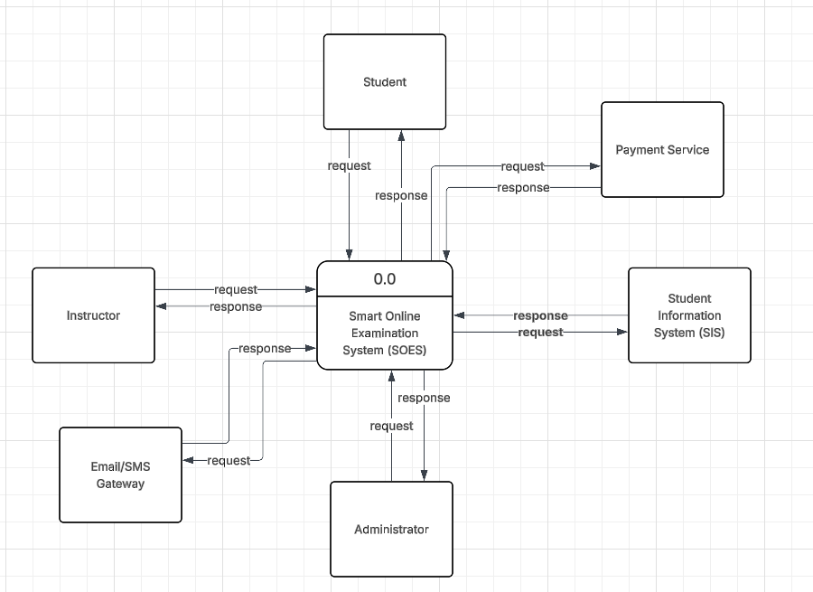

Central Process:
- Smart Online Examination System (SOES) – Located at the center of the diagram , this is the main system process that interacts with multiple external entities
External Entities:
- Student
Sends request to SOES
Receives response from SOES
- Payment Service
Sends response to SOES
Receives request from SOES
- Instructor
Sends request to SOES
Receives response from SOES
- Student Information System (SIS)
Sends response to SOES
Receives requests from SOES
- Email/SMS Gateway
Sends response to SOES
Receives requests from SOES
- Administrator
Sends request to SOES
Receives response from SOES

Data Flow Diagram Level – Smart University Online Examination System (SOES)

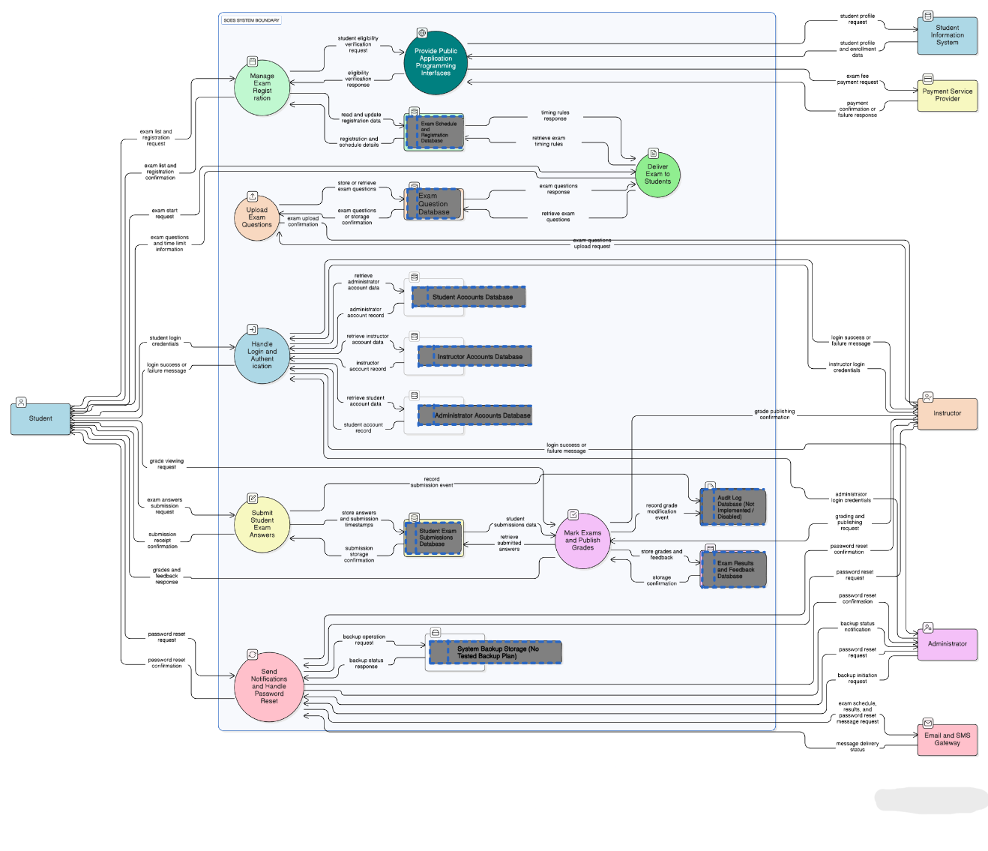

Overview and Purpose
The Smart University Online Examination System (SOES) is modeled using a Level 1 Data Flow Diagram to describe how examination activities and sensitive data move between users , internal processes , data stores , and external integrated systems The diagram includes the system boundary , major functional processes (login , registration , exam delivery , submission , grading , notifications , and API integration) , persistent data stores , bidirectional data flows , and trust boundaries that highlight points of elevated security risk

1 System Boundary
All SOES internal processes and data stores are contained inside a single boundary labeled “SOES System Boundary ” All human users and integrated third-party services are positioned outside this boundary This separation clarifies what is controlled by SOES versus external actors and helps recognize trust changes where threats are more likely to occur

2 External Entities
The DFD shows three user entities and three integrated external systems:
Human Users (Left side)
- Student: logs in , registers for exams , starts exams , submits answers , views grades , and requests password resets
- Instructor: logs in , uploads exam questions , marks exams , publishes grades , and requests password resets
- Administrator: logs in , manages system operations including backup actions , and requests password resets
External Integrated Systems (Right side)
- Student Information System: provides student profile and enrollment data for eligibility validation
- Payment Service Provider: processes exam fee payments and provides payment confirmations or failure responses
- Email and SMS Gateway: delivers exam notifications and password reset messages and returns delivery status

3 Internal Processes (SOES)
The system is decomposed into eight internal processes , all named with verb-based descriptions:
- Handle Login and Authentication
Validates login credentials for students , instructors , and administrators , and retrieves account records from the relevant user account databases
- Provide Public Application Programming Interfaces
Acts as the integration layer between SOES and external systems , supporting eligibility verification via the Student Information System and payment processing via the Payment Service Provider This process also reflects the scenario concern that some APIs may be public and unauthenticated
- Manage Exam Registration
Handles student requests to view available exams and register It updates and retrieves records from the exam schedule and registration database and requests eligibility verification through the API layer
- Upload Exam Questions
Supports instructors uploading exam questions and storing or retrieving exam question records from the exam question database
- Deliver Exam to Students
Provides students with exam content and time constraints by retrieving exam questions and timing rules from internal data stores
- Submit Student Exam Answers
Stores submitted student answers and timestamps in the student submissions database and records submission events in the audit log database (marked as not enabled)
- Mark Exams and Publish Grades
Allows instructors to publish grades , enables students to view grades , retrieves student submissions for marking , stores grades and feedback in the results database , and records grade modification events in the audit log database
- Send Notifications and Handle Password Reset
Manages password reset requests for all user types , sends schedule/results/reset messages through the email and SMS gateway , and coordinates optional backup operations with backup storage

4 Data Stores
Your DFD uses separate data stores for different user types (as required) and includes optional security-related stores
User Databases (Separated)
- Student Accounts Database
- Instructor Accounts Database
- Administrator Accounts Database
Examination Databases
- Exam Question Database
- Exam Schedule and Registration Database
- Student Submissions Database
- Exam Results and Feedback Database
Optional / Control Databases
- Audit Log Database (Not Enabled)
Included to represent missing logging capability in the scenario
- Backup Storage (No Tested Backup Plan)
Included to reflect the absence of a tested backup and recovery plan

5 Key Data Flows
Authentication and Account Verification
Students submit login credentials to the login process , and the login process retrieves student account records from the Student Accounts Database Instructor and administrator authentication also occurs through the same process , with account records retrieved from their separate databases Authentication results are returned back to each user
Exam Registration and Eligibility Validation
Students send exam registration requests to Manage Exam Registration , which reads and updates records in the Exam Schedule and Registration Database Eligibility verification is performed by sending a request to the Provide Public Application Programming Interfaces process
External Integration through the API Layer
The API process requests student profile data from the Student Information System and receives enrollment information in return It also sends payment requests to the Payment Service Provider and receives payment confirmations or failure responses
Question Upload and Storage
Instructors interact with Upload Exam Questions , which stores and retrieves questions from the Exam Question Database , and returns an upload confirmation response
Exam Delivery
Students request to start the exam through Deliver Exam to Students The process retrieves exam questions from the Exam Question Database and timing rules from the Exam Schedule and Registration Database , then provides students with exam questions and time limit information
Answer Submission and Storage
Students submit answers using Submit Student Exam Answers , which stores answers and timestamps in the Student Submissions Database and records the submission activity in the audit log database (even though it is marked as not enabled)
Grading and Grade Publishing
Students send grade-viewing requests to Mark Exams and Publish Grades , while instructors receive grade publishing confirmation The process retrieves submissions from the Student Submissions Database , stores grades and feedback in the Exam Results and Feedback Database , and records grade modifications in the audit log database
Notifications and Password Reset
Students request password reset through Send Notifications and Handle Password Reset and receive confirmation Instructors and administrators request password reset and receive confirmations as well Messages are sent to the Email and SMS Gateway , and delivery status responses return back to SOES Optional backup operations are modeled through interactions with backup storage and administrator notifications

6 Trust Boundaries (Security Exposure Points)
- User boundary (Student/Instructor/Administrator ↔ SOES): reflects weak authentication , password sharing , and brute-force attempts
- API boundary (SOES API ↔ Student Information System): reflects risk of unencrypted HTTP communication and possible interception
- API boundary (SOES API ↔ Payment Service Provider): reflects exposure from public and unauthenticated APIs
- Messaging boundary (SOES ↔ Email and SMS Gateway): reflects password reset without identity verification and the risk of account takeover
- Backup boundary (SOES ↔ Backup Storage): reflects the lack of a tested backup plan and potential recovery failures during attacks

Question 4
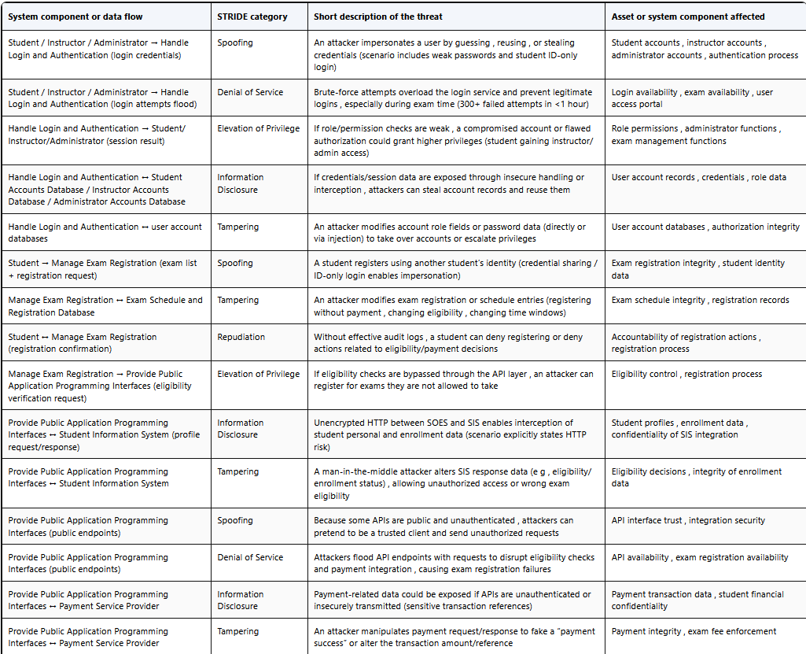
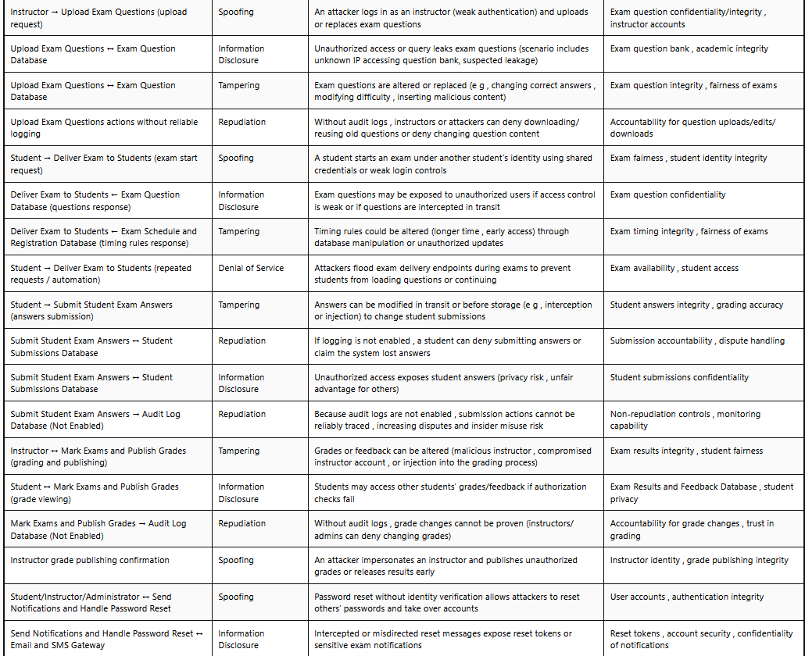
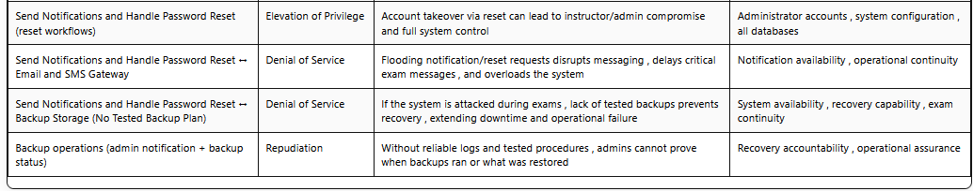

Question 5

1-Applying the DREAD Method
After recognizeing threats using the STRIDE methodology in Question 4 , each threat is quantitatively evaluated using the DREAD risk assessment model ,The purpose of DREAD is to prioritise threats based on severity and likelihood so that mitigation efforts focus on the most critical risks
Each threat is scored from 1 (very low) to 10 (very high) for the following factors:
- Damage Potential (D): Impact if the threat is successfully exploited
- Reproducibility (R): How easily the attack can be repeated
- Exploitability (E): Effort and skill required to carry out the attack
- Affected Users (A): Number of users impacted
- Discoverability (D): How easy it is to discover the vulnerability
The Average DREAD Score is calculated as:
$$\text{Average DREAD}=\frac{D+R+E+A+D}{5}$$

2 Full DREAD Scoring Table (All STRIDE Threats from Question 4)
This table directly corresponds to the STRIDE threats identified per process , data store , and trust boundary in your DFD
DREAD Risk Assessment Table

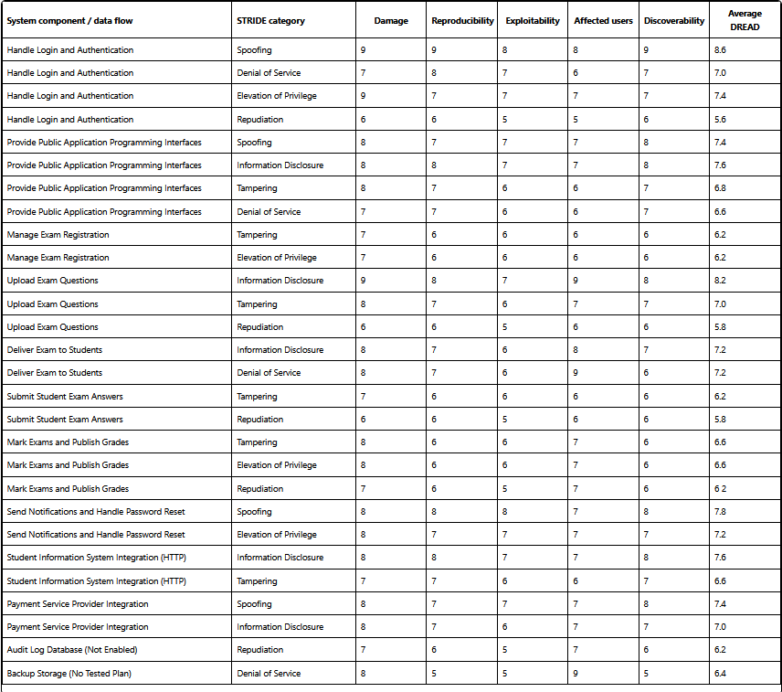

3 Identification of the Three Highest-Priority Risks
After calculating the average DREAD values for all identified threats , the three threats with the highest scores are classified as high-priority risks
High-Priority Risk 1: Weak Authentication and Identity Spoofing
- Component: Handle Login and Authentication
- Average DREAD Score: 8.6
Reason:
This threat has the highest score due to extremely weak authentication controls , password sharing , and observed brute-force attacks Successful exploitation allows attackers to impersonate students , instructors , or administrators and enables multiple follow-on attacks

High-Priority Risk 2: Exam Question Leakage
- Component: Upload Exam Questions / Exam Question Database
- Average DREAD Score: 8.2
Reason:
The exam question database is the most valuable academic asset Leakage compromises fairness , integrity , and university reputation The scenario explicitly reports suspected question leakage before exams

High-Priority Risk 3: Password Reset Abuse Without Identity Verification
- Component: Send Notifications and Handle Password Reset
- Average DREAD Score: 7.8
Reason:
Password reset requests do not require identity verification , allowing attackers to take over accounts , including privileged accounts This threat is highly discoverable and easy to exploit

4 Why These Threats Are More Critical Than Others
These three threats are more critical because they:
- Are explicitly observed or implied in the scenario
- Affect core security objectives (authentication , integrity , confidentiality)
- Enable multiple secondary attacks
- Impact a large number of users
- Have high likelihood of exploitation
Lower-scoring threats (such as missing backups or repudiation risks) are still important but generally become critical after one of the high-priority threats succeeds

Question 6

In Question 5 , 3 threats were identified as high priority risks based on their high DREAD scores
In this section realistic mitigation measures are proposed for each threat Each control is classifid as administrativ ,technical , or physecal , and the DREAD score is recalculated to evaluate whither the applied controls effectivly reduce the risk
The objective is to demonestrate how appropriate security controls lower likelihod and impact , and therefore reduc overall risk exposure

High-Priority Threat 1: Weak Authentication and Identity Spoofing
Threat Summary
- Component: Handle Login and Authentication
- STRIDE Category: Spoofing
- Original Average DREAD Score: 8.6 (High Risk)
This threat exists due to weak authntication mechanesms , password sharing , lack of multi_factor authentication , and observed brute_force login attempts

Proposed Mitigation Measures
Mitigation Control | Control Type | Explanation
Enforce strong password policy | Technical | Require minimum length , complexity , and periodic password changes
Implement Multi-Factor Authentication (MFA) | Technical | Adds a second factor (email OTP or mobile app) to prevent credential-only access
Account lockout and rate limiting | Technical | Limits login attempts and prevents brute-force attacks
Security awareness training | Administrative | Educates users about password sharing and credential protection

Recalculated DREAD Score (After Mitigation)
DREAD Factor | Before | After | Justification
Damage Potential | 9 | 7 | Impact remains high but reduced due to layered defenses
Reproducibility | 9 | 4 | MFA and lockout prevent repeated attacks
Exploitability | 8 | 4 | Attacks require additional credentials
Affected Users | 8 | 5 | Fewer accounts compromised
Discoverability | 9 | 5 | Security controls reduce visibility of attack paths
New Average DREAD Score:
$$\frac{7+4+4+5+5}{5}=5.0$$

Evaluation
The risk level is reducede from high to medium
The mitgations are efective , as they directly address the rot causes of spoofing by strengthning authentcation and limting attack feasiblity The residual risk is acceptable but still requires continuous monitoring

High-Priority Threat 2: Exam Question Leakage
Threat Summary
- Component: Upload Exam Questions or Exam Question Database
- STRIDE Category: Information Disclosur
- Original Average DREAD Score: 8.2 High Risk
This threat is critcal because leaked exam questions undermine academic integrity and university reputation

Proposed Mitigation Measures
Mitigation Control | Control Type | Explanation
Encrypt data at rest and in transit | Technical | Protects exam questions from interception and unauthorized access
Role-Based Access Control (RBAC) | Technical | Limits question access to authorized instructors only
Mandatory VPN for instructors | Technical | Secures uploads from external networks
Regular access review | Administrative | Ensures only active instructors retain access
Disable reuse of old questions | Administrative | Reduces exposure of previously compromised content

Recalculated DREAD Score (After Mitigation)
DREAD Factor | Before | After | Justification
Damage Potential | 9 | 7 | Impact still high but likelihood reduced
Reproducibility | 8 | 4 | Encryption and access controls limit repeat attacks
Exploitability | 7 | 4 | Requires privileged access and VPN
Affected Users | 9 | 6 | Limited scope of compromise
Discoverability | 8 | 4 | Reduced exposure of the question bank
New Average DREAD Score:
$$\frac{7+4+4+6+4}{5}=5.0$$

Evaluation
The risk is reducd from high to medium
These mitigations are highly effective , as they protecte the system”s most valuable asset using defense_in_depth This threat remains important and should be continuously audited

High-Priority Threat 3: Password Reset Abuse Without Identity Verification
Threat Summar
- Component: Send Notificatons and Handle password reset
- STRIDE Category: Spoofing / Elevation of Privilege
- Original Average DREAD Score: 7.8 High Risk
Password reset mechanisms without identity verification allow attackers to hijack accounts , including privileged ones

Proposed Mitigation Measures
Mitigation Control | Control Type | Explanation
Identity verification for password reset | Technical | Use email OTP or security questions
Expiring reset tokens | Technical | Prevents reuse of reset links
Password reset attempt monitoring | Technical | Detects suspicious behavior
Incident response procedures | Administrative | Defines response to account takeover attempts

Recalculated DREAD Score (After Mitigation)
DREAD Factor | Before | After | Justification
Damage Potential | 8 | 6 | Reduced likelihood of account takeover
Reproducibility | 8 | 4 | Tokens expire quickly
Exploitability | 8 | 4 | Requires access to verified identity channel
Affected Users | 7 | 5 | Fewer accounts affected
Discoverability | 8 | 4 | Reset flow less predictable
New Average DREAD Score:
$$\frac{6+4+4+5+4}{5}=4.6$$

Evaluation
The risk is reduced from high to medium_low
These controles significantly reduce the attack surface and prevent automated account takeover attempts The mitgation is effective and proportionate

Overall Critical Evaluation
Threat | Original DREAD | New DREAD | Risk Reduction
Weak Authentication | 8.6 | 5.0 | High → Medium
Exam Question Leakage | 8.2 | 5.0 | High → Medium
Password Reset Abuse | 7.8 | 4.6 | High → Medium–Low
Key Findings:
- All 3 risks show substanitial reduction
- Technical controls provide the strongeste impact
- Administrative controls support long term sustainablity
- No physical controls are required due to the system”s digital nature

Conclusion
The applied mtigations succesfully reduce both the likelihood and impact of the highest_ priority threats
While residual risk remain, it is within acceptable levels and aligns with best practics from STRIDE , DREAD , and the Secure Development

Activity 3 – Quantitative Risk Analysis Using the FAIR Methodology

Question 7

FAIR Methodology Overview
The Factor Analysis of Information Risk (FAIR) methodology is a quantitative risk assessment methodology that measures cyber risk in a reasonable and defensible manner risk in FAIR is the likely occurrence, and the likely amount of future loss (typically measured over one year of time) rather than using broad terms such as high or low, FAIR breaks risk into measurable factors, estimates them using realistic scales, and then rationalizes them to form a definite perspective of risk exposure. Under the Smart Online Examination System (SOES) FAIR assists the university to analyze the risks of leakage of examination questions during examinations, brute-force logins, or interception of student data between SOES and SIS, by determining the frequency with which such risks may occur, and the degree of loss that may result.
Main FAIR Components
1) Threat Event Frequency (TEF)
Threat Event Frequency determines the number of times the threat actor is likely to take action against the system and cause a system to become harmed within a specific period (usually in one year).
TEF in SOES may indicate the frequency of attackers performing actions like:
- attempting to crack the passwords of instructors or administrators,
- in an effort to get the exam question database,
- soaking and exploiting public application programming interfaces.

2) Vulnerability
In FAIR, vulnerability refers to the probability that a threat event will succeed (turn into a loss event). Vulnerability relies on whether the capability of attacker is more than the strength of resistance of the system (against the attacker) (system controls).
SOES has high vulnerability in instances like:
- no multi-factor authentication and weak authentication,
- authentication-free public application programming interfaces,
- unsecured transmissions (HTTP) which may be intercepted.

3) Loss Event Frequency (LEF)
Loss Event Frequency refers to the extent of the frequency of a threat event actually incurring loss.
And in FAIR, it is typically represented by:
Loss Event Frequency = Threat Event Frequency multiplied by the Vulnerability.
In SOES, repeated attacks lead to successful incidents (LEF) only when the system is vulnerable (high TEF). Although it may be the case that there are many attempts made (high TEF), it is the vulnerability of the system that predisposes how many attempts will be successful.

4) Primary Loss Magnitude (PLM)
Primary Loss Magnitude is the actual financial effect that the university suffers directly after an occurrence of a loss without relying on the reaction of others.
Primary losses in SOES may consist of:
- costs after a compromise of the system recovery and incident response,
- approximate hours that the information technology team would spend on overtime due to exam disruption,
- delays of exams due to operational downtime,
- recreating lost corrupt exam schedules or student submissions.

5) Secondary Loss Magnitude (SLM)
Secondary Loss Magnitude are other losses that are as a result of secondary reactions of stakeholders, like regulators, students, parents, and the media. This is because outsiders react to the incident.
Secondary losses in SOES would include:
- legal action by the students in case of examination leakage or manipulation of results,
- financial fines in the event of exposure of personal data,
- costs to inform the affected users and address complaints,
- PR costs and possible student trust that might be lost concerning enrollment.

The Difference Between FAIR and Traditional Qualitative Risk Assessment
Conventional qualitative risk assessment typically scores risks on descriptive scale like low to high where often shown in heat maps. These scales are quick to complete, though they can be subjective and hard to justify since they are defined differently by different individuals and they do not correlate with quantifiable business impact.
FAIR differs because it:
- Eschews labels in favor of numbers and ranges.
Frequency within a time period is estimated by FAIR instead of being specified as high likelihood (such as but not limited to between 1 and 5 attempts per year).
- Distinguishes between frequency and magnitude.
FAIR compels the analysts to estimate the frequency of occurrence (LEF) of something and the cost (LM) of something, instead of combining them into a single and unclear score.
- Generate defendable and business friendly results.
FAIR presents the risk in the form of a distribution of potential financial losses (annualized loss exposure) which aids decisions on the cost-benefit, including whether or not to add multi-factor authentication is worth the investment.
- Concentrates on the probability, not mere possibility.
Qualitative approaches are usually concerned with worst-case scenarios. FAIR is concerned with what is probable within a given timeframe, although uncertainty is still represented in ranges.

Question 8

Quantitative risk measurement is valuable as it offers objective, measurable and defensible data that can be used in making better decisions making , While qualitative risk assessment methods (such as high/medium/low ratings) are useful for quick overviews , they are often insufficient for complex systems like the SOES , which handls sensitiv academic data , financial transactions , and high-availability exam services Quantitative methods , such as the FAIR methodology , overcome many of the limitations of qualitative approaches by focusing on probability , financial impact , and uncertainty

Significance of quantifying Risk.
in SOES, the university will have to determine the priorities of which risks to mitigate initially and the extent of investment in security measures Quantitative risk analysis will allow the decision-maker to:
have a knowledge about the frequency of security incidences,
calculate the possible financial and operating losses,
rank various risks on a scale of common (e.g. exposure to annual loss) ,
approve investments like multi-factor authentication, encrypted communication, or monitoring.
In the absence of quantified risk, decisions can be made out of either fear, assumptions or the most recent occurrence instead of evidence.

Comparison of the Quantitative and Qualitative Risk Evaluation..
1 Measurement Approach
Risk Assessment-Qualitative.
Makes use of descriptive terms like low, medium and high These are subjective terms which are based on a large degree of personal opinion.
The Quantitative Risk Assessment....
Applies numerical values, probabilities, and ranges (e.g. number of incidents per year or financial loss in currency) FAIR approximates risk with frequency and magnitude distributions.
SOES Example:
A quantitative analysis of the nature of a brute-force attack on instructor accounts may be considered to be of high risk, and the quantitative analysis can demonstrate that the incidents may take place more than once a year and may result in a certain estimated financial and operational loss, therefore, the risk is quantifiable.

2 Decision-Making Support
Risk Assessment by Qualitative Method..
General prioritization but does not facilitate cost-benefit analysis It is hard to explain why one control should be funded as compared to another.
Quantitative Risk Assessment
Aids informed decisions where the anticipated loss is weighed against the mitigation control cost.
SOES Example:
FAIR would assist the university in benchmarking the anticipated loss due to account compromise annually against the security cost associated with the deployment of multi-factor authentication This will allow the leadership to use financial premises as a justification of security expenditure, as opposed to speculations.

3 Consistency and Communication.
Qualitative Risk Assessment
People and departments interpret it differently What is a high risk to one person may be the medium risk of another, resulting in a lack of consistency in prioritizing it.
Quantitative Risk Assessment
Applies standard measurements and definite periods of time, enhancing uniformity and interaction with non-technical and technical stakeholders.
SOES Example:
In reporting risks to the university management it is more effective and practical to say that due to the fact that data interception can lead to an estimated loss of between X and Y annually rather than merely indicate that it is a high risk.

4 Handling Uncertainty
Qualitative Risk Assessment
Frequently disregards ambiguity or covers it with pre-determined categories.
Quantitative Risk Assessment
Models uncertainty explicitly through the use of ranges as well as probability distributions as it appears in the real world.
SOES Example:
There is no guarantee that the risk of data leakage of the examination data will happen annually, however, quantitative analysis can demonstrate the probability of the event and the range of losses which the university can expect to incur to act in the situations which might take place rather than on the basis of extreme assumptions.

Conclusion
Although qualitative risk assessment can be convenient in case of initial screening and awareness, it cannot be utilized alone to manage the complex information systems such as the SOES Quantitative risk analysis, particularly with the use of FAIR will offer better and more accurate, consistent and defensible knowledge of risk and the university can prioritize controls, allocate resources and make wise decisions based on the technical and business objectives.

Question 9

Selected High-Priority Threat (from Question 5): Exam Question Leakage
This threat was one of the highest-scoring risks under DREAD because it targets the most valuable academic asset in SOES (exam questions) and directly threatens fairness and integrity

1 Risk Scenario Definition (FAIR Style)
FAIR requires a clearly scoped scenario (not a vague statement like “data leakage is risky”) The scenario must define the asset , the threat community , the threat type , and the effect
Risk Scenario (FAIR statement):
A malicious threat agent (cyber criminal or non-privileged insider such as a student) gains unauthorized access—either through weak authentication , insecure upload practices , or insufficient access control—to the Exam Question Database or to the upload channel , and leaks exam questions before the scheduled exam date , causing loss exposure to HTU
Asset at risk (the “real asset” in FAIR terms):
Exam question content (academic intellectual property and assessment material)
In FAIR , the server or database is often only the container, the “thing of value” is the data itself
Primary stakeholder:
Al-Hussein Technical University (HTU) as the organization suffering direct and indirect losses
Threat community (TCom):
- Non-privileged insiders (students who do not have authorized access to the question bank)
- Cyber criminals (external attackers motivated by profit or selling leaked content)
Threat type: Malicious act (intentional)
Effect classification (CIA):
- Primary: Confidentiality (questions disclosed before exam)
- Secondary consequence: Integrity of the assessment process (fairness and grading validity become questionable)
FAIR recommends classifying by the effect that drives the most meaningful loss exposure, here confidentiality triggers the major loss event , and integrity damage amplifies impact

2 FAIR Factor Definitions and Assumptions
Because SOES does not provide exact measurement data , FAIR allows using reasonable calibrated estimates (preferably as ranges , not single-point values) These estimates should be documented so the conclusion is defensible , which is a core FAIR principle
2.1 Contact Frequency (CF)
FAIR definition :
The probable frequency within a given timeframe (typically annual) that threat agents come into contact with the asset (logical or physical contact)
SOES context (why contact occurs often):
- Exams are prepared repeatedly across the semester
- Instructors upload questions and may reuse stored questions
- The system is cloud hosted and accessed through the internet
- Some instructors upload from home on personal laptops (increasing exposure)
Estimate (annual range):
CF = 10 to 15 contacts per year
Justification:
A realistic estimate is that multiple “contact opportunities” occur across midterms , quizzes , finals , and departmental exams Each exam cycle introduces repeated interactions with question assets (uploading , editing , reviewing , retrieving) Even if the number of exams is lower , the number of access events around each exam increases contact opportunities

2.2 Probability of Action (PoA)
FAIR definition :
The probability a threat agent will attempt to act against the asset once contact has occurred PoA applies to thinking agents (humans) , and it depends on perceived value , effort , and risk to the attacker
SOES assumptions aligned with scenario:
- Exam questions have extremely high value to students (guaranteed advantage)
- The scenario already reports suspicious access attempts before midterm exams
- Weak controls (no MFA , weak authentication practices) lower attacker effort
- Lack of audit logs reduces perceived risk of being caught
Estimate:
PoA = 0.40 to 0.60 (40%–60%)
Justification:
Given strong motivation and observed suspicious activity , once an attacker finds an access opportunity , there is a moderate-to-high likelihood they will attempt exploitation rather than ignore it

2.3 Threat Capability (TCap)
FAIR definition :
Threat Capability represents the skills and resources of a threat agent population , expressed along a percentile continuum (1–100)
SOES assumptions:
- External attackers and skilled students can use common web exploitation methods (credential stuffing/brute force , insecure APIs , weak session management , poor access control)
- The scenario indicates weak authentication and multiple failed login attempts targeting privileged accounts
- No MFA means attackers require lower skill to succeed compared to well-protected systems
Estimate:
TCap = 70th to 80th percentile
Justification:
This is not a nation-state level operation , but it is above average because the attacker only needs standard tools and moderate skill , and the system has weaknesses that reduce the required sophistication

2.4 Resistance Strength (RS)
FAIR definition:
Resistance Strength (or “difficulty”) reflects how hard the control environment makes it for the attacker It is compared against TCap: if threat capability exceeds resistance strength , vulnerability is higher
SOES evidence from scenario:
- No multi-factor authentication
- Weak password practices (students logging in using student ID only, password sharing reported)
- No audit logs / no alerts for unauthorized access
- Some insecure communication practices (HTTP in parts of system and unsafe upload environments)
- Old accounts not removed (expanded attack surface)
Estimate:
RS = 40th to 55th percentile
Justification:
Controls exist (login exists , databases exist) but are weak , inconsistently enforced , and not monitored Therefore , resistance strength is below the likely capability of a motivated attacker

(FAIR reasoning link) Vulnerability interpretation (not required , but strengthens correctness)
In FAIR , vulnerability increases when TCap > RS
Here , TCap (70–80) is above RS (40–55) , so the probability that a threat event becomes a loss event is meaningfully high

2.5 Primary Loss Magnitude (PLM)
FAIR definition:
Primary loss magnitude is the direct loss HTU experiences from the event not dependent on secondary stakeholder reactions
Primary loss types consistent with FAIR “forms of loss”:
- Response costs: incident handling , investigation , forensic review , IT overtime
- Productivity losses: disruption to exam schedules , delays , operational interruption
- Replacement costs: rewriting exam questions , re-preparing multiple exam versions
- Remediation costs: strengthening access control , urgent patching , emergency control deployment
Estimate (per incident):
PLM = $20 ,000 to $60 ,000
Justification:
A single leakage event can force rewriting multiple exams and implementing emergency actions The loss is significant but likely remains within tens of thousands for one major incident , assuming no massive system rebuild is required

2.6 Secondary Loss Magnitude (SLM)
FAIR definition :
Secondary loss magnitude is loss suffered by the primary stakeholder because of secondary stakeholder reactions (students , parents , regulators , media , accreditation bodies)
Secondary stakeholder reactions relevant to SOES:
- Formal student complaints and appeals
- Academic investigations and administrative burden
- Potential legal disputes (students claiming unfairness or damages)
- Regulatory or accreditation scrutiny
- Loss of enrollment trust and reputational consequences (reputation is an outcome in FAIR , but it can create financial loss through lost revenue)
Estimate (per incident):
SLM = $50 ,000 to $150 ,000
Justification:
Secondary losses often exceed primary losses because they include longer-term effects: dispute resolution , legal fees , and potential loss of student confidence Even if no direct regulatory fine occurs , secondary response costs and lost demand can be substantial

3 Summary Table (FAIR Inputs)
FAIR factor | Estimated value | Rationale (SOES context)
Contact Frequency (CF) | 10–15 per year | Multiple exam cycles and repeated access during preparation and uploads
Probability of Action (PoA) | 0 40–0 60 | High perceived value + weak controls + reduced risk of detection
Threat Capability (TCap) | 70th–80th percentile | Skilled students/external attackers using common techniques
Resistance Strength (RS) | 40th–55th percentile | No MFA , weak authentication practices , no audit logs/alerts , expanded attack surface
Primary Loss Magnitude (PLM) | $20 ,000–$60 ,000 | Response + productivity disruption + replacement of exam materials
Secondary Loss Magnitude (SLM) | $50 ,000–$150 ,000 | Appeals , legal/administrative burden , accreditation pressure , enrollment trust impacts

4 Conclusion (FAIR Value)
This analysis demonstrates the benefit of FAIR compared to qualitative labels like “high risk ” Instead of relying on subjective ratings , the threat is explained using a cause-and-effect model:
- SOES has frequent exposure to the asset (high contact frequency) ,
- threat agents have strong motivation (high probability of action) ,
- the threat community’s capability is higher than the system’s resistance strength , indicating high vulnerability ,
- and the expected loss exposure includes both primary losses (direct operational and response cost) and secondary losses driven by stakeholder reactions
Therefore , exam question leakage remains a justified high-priority risk , and the FAIR inputs provide a defensible basis for investing in stronger controls such as MFA , strict access control to question assets , secure upload practices , encryption in transit , and audit logging/monitoring to increase resistance strength and reduce vulnerability

Question 10

Based on the FAIR-U Excel risk analysis conducted for the Exam Question Leakage scenario in the SOES, the following quantitative risk results were obtained.

FAIR Risk Results Summary Table
Metric | Result | Interpretation
Loss Event Frequency (LEF – Average) | 6.1 events per year | Successful loss events are expected to occur multiple times annually due to frequent access, high attacker motivation, and weak resistance controls
Loss Magnitude (LM – Average per event) | $142,352 | The average financial impact of a single exam leakage incident, combining primary and secondary losses
Loss Magnitude (10th Percentile) | $73,249 | Optimistic scenario where impact is relatively limited
Loss Magnitude (90th Percentile) | $233,751 | Severe but plausible per-incident impact
Annualized Loss Exposure (ALE – Average) | $864,684 per year | Expected annual financial loss to the university
Minimum Annual Loss | $372,939 | Best-case annual outcome
Maximum Annual Loss | $1,665,841 | Worst-case modeled annual outcome
Likelihood of Any Loss | 99.5% | A loss occurring within the year is almost certain

Analysis and Interpretation
1. Loss Event Frequency (LEF)
The FAIR model estimates an average LEF of 6.1 loss events per year, indicating that exam question leakage is a recurring risk rather than a rare incident. This is driven by:
- Frequent access to exam questions throughout the academic year,
- High attacker motivation (students and external attackers),
- Weak resistance controls (no MFA, limited monitoring),
- Threat capability exceeding resistance strength.

2. Loss Magnitude (LM)
The average loss magnitude of $142,352 per event reflects the combined impact of:
- Primary losses: exam rewriting, IT incident response, operational disruption,
- Secondary losses: student complaints, academic investigations, reputational damage, and potential legal or regulatory exposure.
Even a single successful leakage incident can therefore result in significant financial loss.

3. Annualized Loss Exposure (ALE)
The Annualized Loss Exposure of approximately $865,000 per year represents the university’s expected yearly financial risk from this single scenario.
From a management perspective:
- Any mitigation control costing significantly less than the ALE (such as MFA, access controls, logging, and monitoring) is economically justified,
- ALE allows leadership to compare this risk against other institutional risks using a common financial scale.

Conclusion
The FAIR analysis demonstrates that exam question leakage in SOES is a high-frequency, high-impact risk. Without improvements to authentication, monitoring, and access control, the university faces substantial and recurring financial losses every year. The quantitative FAIR results provide a defensible and business-oriented basis for prioritizing cybersecurity investments and governance actions.

Question 11

1. Scenario Description
Selected Threat Scenario
The selected high-priority threat is Exam Question Leakage in the Smart Online Examination System (SOES).
FAIR Risk Scenario Statement
A malicious threat actor (non-privileged student or external cybercriminal) gains unauthorized access to the Exam Question Database or the exam upload channel through weak authentication, insufficient access controls, or insecure system practices, and leaks exam questions before the scheduled examination date, resulting in financial, operational, and reputational losses to the university.
Asset at Risk
The primary asset is exam question content, which represents high-value academic intellectual property.
In FAIR terms, the database or system is only a container, the true asset is the confidential assessment material.
Threat Community
- Non-privileged insiders (students)
- External cybercriminals
Threat Type
Malicious, intentional act
Primary Effect
- Confidentiality breach (exam questions disclosed before exams)
Secondary Effects
- Integrity of assessments compromised
- Loss of trust in grading fairness
- Administrative and reputational consequences

2. FAIR Variables, Assumptions, and Data Sources
Because exact historical loss data is unavailable, reasonable, calibrated assumptions were used, which is consistent with FAIR best practices.

2.1 Contact Frequency (CF)
Definition: Number of times per year a threat actor comes into contact with the asset.
- Minimum: 10
- Most Likely: 12
- Maximum: 15
Assumptions:
- Multiple exam cycles per year (midterms, quizzes, finals)
- Frequent uploads and access by instructors
- Internet-accessible system, sometimes from personal devices
Source of Data:
- Academic calendar patterns
- System usage behavior
- Expert judgment

2.2 Probability of Action (PoA)
Definition: Likelihood that a threat actor will attempt to act once contact occurs.
- Minimum: 40%
- Most Likely: 50%
- Maximum: 60%
Assumptions:
- High perceived value of exam questions
- Weak deterrence (no MFA, limited monitoring)
- Reduced fear of detection
Source of Data:
- Scenario observations
- FAIR qualitative guidance
- Expert judgment

2.3 Threat Capability (TCap)
Definition: Skill and capability level of the threat community relative to FAIR’s capability continuum.
- Minimum: 70%
- Most Likely: 75%
- Maximum: 80%
Assumptions:
- Attackers use common tools (credential stuffing, brute force)
- No need for advanced exploits
- System weaknesses reduce required skill
Source of Data:
- MITRE ATT&CK techniques
- Academic environment threat profiles

2.4 Resistance Strength (RS)
Definition: Strength of existing controls to resist the threat.
- Minimum: 40%
- Most Likely: 50%
- Maximum: 55%
Assumptions:
- No multi-factor authentication
- Weak password practices
- Lack of audit logs and alerting
- Poor account lifecycle management
Source of Data:
- Scenario description
- Control maturity assessment
FAIR Interpretation:
Because TCap > RS, system vulnerability is high.

2.5 Loss Event Frequency (LEF)
Calculated by the FAIR model using Monte Carlo simulation:
- Minimum: 4.0 events/year
- Average: 6.1 events/year
- Maximum: 9.0 events/year

2.6 Primary Loss (PL)
Definition: Direct losses suffered by the university.
- Minimum: $20,000
- Most Likely: $55,000
- Maximum: $125,000
Examples:
- Exam rewriting
- IT incident response
- Operational disruption

2.7 Secondary Loss Event Frequency (SLEF)
Definition: Percentage of primary events that trigger secondary stakeholder reactions.
- Minimum: 40%
- Most Likely: 70%
- Maximum: 90%

2.8 Secondary Loss Magnitude (SLM)
Definition: Losses driven by external reactions.
- Minimum: $30,000
- Most Likely: $100,000
- Maximum: $250,000
Examples:
- Student complaints and appeals
- Reputational damage
- Legal and regulatory exposure

3. Final Calculated FAIR Results
From FAIR Model Output
Loss Event Frequency (LEF)
- Average: 6.1 events/year
Loss Magnitude (LM per event)
- Minimum: $73,249
- Average: $142,352
- Maximum: $233,751
Annualized Loss Exposure (ALE)
- Minimum: $372,939
- Average: $864,684
- Maximum: $1,665,841
- Likelihood of Any Loss: 99.5%

4. Interpretation of Findings
The FAIR results show that exam question leakage is:
- High-frequency: Occurs multiple times per year
- High-impact: Each incident costs six figures
- Highly probable: Near certainty of annual loss
This indicates a weak risk posture for SOES, where current controls are insufficient to protect high-value academic assets. The risk is systemic, not incidental, and requires immediate mitigation.

5. Recommendations and Cost–Benefit Discussion
Recommended Risk Reduction Measures
- Multi-Factor Authentication (MFA) for instructors and administrators
- Strict role-based access control to exam question assets
- Audit logging and real-time monitoring
- Secure upload channels and encryption in transit
- Regular account review and de-provisioning

Cost–Benefit Analysis
- Estimated ALE ≈ $865,000 per year
- Cost of implementing MFA, logging, and access controls is significantly lower than ALE
- Even a 30–40% reduction in LEF would justify the investment financially
Therefore, implementing these controls is economically and strategically justified.

6. Conclusion
This FAIR analysis demonstrates that exam question leakage in SOES represents a critical cybersecurity risk with recurring and substantial financial impact. By quantifying both frequency and magnitude, FAIR provides a defensible, business-aligned foundation for decision-making. Immediate investment in stronger security controls will significantly improve the university’s risk posture and reduce long-term losses.

Question 12
The Factor Analysis of Information Risk (FAIR) methodology is a quantitative risk analysis framework designed to measure cyber risk using probability and financial impact. While FAIR provides strong advantages over traditional qualitative methods, it also has limitations that must be understood to use it effectively.

Strengths of the FAIR Methodology
1. Realism and Accuracy
One of FAIR’s key strengths is its realistic modeling of cyber risk. Instead of relying on subjective labels such as “high” or “low,” FAIR defines risk as the probable frequency and probable magnitude of loss within a given timeframe. This reflects how risk actually manifests in real-world systems.
In the Smart Online Examination System (SOES), FAIR allowed exam question leakage to be modeled as a recurring event with measurable financial consequences, rather than as a hypothetical worst-case scenario. This realism helps organizations focus on what is likely to happen, not just what is possible.

2. Mathematical Visibility and Transparency
FAIR makes the logic behind risk calculations explicit by breaking risk into clearly defined factors such as Contact Frequency, Probability of Action, Threat Capability, Resistance Strength, and Loss Magnitude. Each step in the calculation is visible and traceable.
This transparency improves trust in the results and allows analysts to explain exactly why a risk has a certain value. In the SOES analysis, it was clear how weak authentication controls and high attacker capability led to higher Loss Event Frequency, making the results defensible and auditable.

3. Strong Decision-Making Support
FAIR expresses risk in financial terms, which aligns cybersecurity discussions with business decision-making. By producing values such as Annualized Loss Exposure (ALE), FAIR enables cost–benefit analysis.
For example, in the SOES case, an ALE of approximately $865,000 per year provided clear justification for investing in controls such as multi-factor authentication and monitoring. This makes FAIR particularly valuable for communicating risk to senior management and non-technical stakeholders.

Limitations of the FAIR Methodology
1. Dependency on Data Quality and Assumptions
FAIR relies heavily on the quality of input data. When precise historical data is unavailable—as is often the case—analysts must rely on expert judgment and assumptions. Poorly calibrated estimates can reduce the accuracy of the results.
In the SOES scenario, assumptions were required for attacker behavior and loss magnitudes. While FAIR allows this through ranges and confidence levels, the results are only as reliable as the assumptions used.

2. Complexity and Learning Curve
FAIR is more complex than traditional qualitative risk assessment methods. It requires a solid understanding of probability, statistics, and the FAIR factor model. Tools such as the FAIR-U Excel workbook can also appear overwhelming to inexperienced users.
This complexity may limit FAIR’s adoption in organizations with limited risk analysis expertise or resources. Without proper training, users may misuse the model or misinterpret the results.

Conclusion
FAIR’s strengths lie in its realism, transparency, and ability to support business-aligned decision-making through quantitative risk analysis. However, its effectiveness depends on the availability of reliable data and the analyst’s understanding of the methodology. When used correctly, FAIR provides a powerful and defensible approach to cybersecurity risk management, but it requires expertise, discipline, and careful calibration to deliver accurate results.

Activity 4 – Application of the NIST Cybersecurity Framework (NIST CSF)

Question 13

The NIST Cybersecurity Framework (NIST CSF) is a structured set of guidelines and best practices that helps organizations manage and reduce cybersecurity risk in a consistent , organized way In the SOES case , it can be used to structure how HTU protects critical exam assets (question bank , student submissions , grades , and accounts) , ensures continuity during exam periods , and improves trust and compliance by following a clear security lifecycle (Recognize , Protect , Detect , Respond , Recover)
The Five Core Functions (with SOES context)
1) Recognize (ID)
Recognize means understanding the organization’s assets , roles , business environment , and cybersecurity risks so the university knows what must be protected For SOES , this includes inventorying the exam databases , admin/instructor accounts , and integrations (SIS + payment APIs) , and recognizing key risks like weak authentication and unencrypted data flows
2) Protect (PR)
Protect focuses on implementing safeguards to reduce the likelihood and impact of incidents In SOES , this would include strong access control and authentication (e g , MFA) , encryption of exam and student data (in transit and at rest) , and secure instructor upload practices to prevent question leakage
3) Detect (DE)
Detect is about recognizeing cybersecurity events quickly through monitoring and detection processes For SOES , this means enabling audit logs and alerts to detect suspicious access to the question bank , brute-force login attempts (like the 300 failed logins/hour) , and unusual downloads or role changes
4) Respond (RS)
Respond covers actions taken during or after an incident to contain damage and coordinate communication In SOES , response includes isolating compromised instructor/admin accounts , stopping the leak path , investigating the unknown IP access , and coordinating with academic management to decide whether to replace exam questions or reschedule exams
5) Recover (RC)
Recover focuses on restoring services and improving resilience after an incident For SOES , recovery means having tested backups and recovery plans so exams can continue even if the system is attacked , and then improving policies and controls based on lessons learned to avoid repeat incidents

Question 14

Using the SOES scenario , the NIST CSF functions can be applied as a practical roadmap to reduce the main weaknesses already identified in your threat modelling (weak authentication , suspected question leakage , unencrypted SIS link , public APIs , missing logs , and no backup plan)

1) Recognize (ID) — What do we have and what can go wrong?
In SOES , HTU should first recognize and document all critical assets , users , data flows , and risks so security efforts focus on what matters most
How to apply it in SOES (realistic examples):
- Asset inventory (digital assets): create an asset register for the User Databases , Exam Question Database , Student Submissions Database , Grades/Feedback Database , and the cloud database infrastructure
- User and privilege identification: list all user roles (student , instructor , admin) and map privileges (e g , admins can grant roles + manage backups → “high impact accounts”)
- Map data flows and trust boundaries: document integrations and flows مثل:
SOES ↔ SIS (currently HTTP)
SOES ↔ Payment service (some public APIs)
SOES ↔ Email/SMS gateway (password reset flow)
- Risk identification based on scenario evidence: register and prioritize risks such as:
weak login and password sharing ,
brute-force attempts against instructor/admin ,
suspected question bank access from unknown IP ,
old accounts still active

2) Protect (PR) — What safeguards should exist to prevent incidents?
In SOES , Protect means implementing safeguards that reduce the chance of attacks succeeding and protect confidentiality , integrity , and availability of exams
How to apply it in SOES (realistic examples):
- Strengthen authentication and access control
enforce strong password policy + prevent “ID-only” login ,
implement MFA for instructors/admins (and ideally students) ,
apply RBAC and least privilege (students cannot access question DB , instructors limited to their own courses)
- Protect data and communications
enforce HTTPS/TLS everywhere , especially SOES ↔ SIS and app ↔ database connections (stop interception and tampering)
encrypt sensitive data at rest in the cloud database (questions , answers , grades)
- Secure APIs and external integrations
require authentication for all APIs (remove public unauthenticated endpoints) ,
add rate limiting + request validation to reduce abuse
- Secure instructor workflows
require VPN when uploading exams from home ,
ban storing exam files unencrypted on personal laptops , or require full-disk encryption + secure storage

3) Detect (DE) — How do we notice attacks early?
Detect means monitoring and logging so HTU can quickly recognize abnormal activity and stop incidents before they escalate
How to apply it in SOES (realistic examples):
- Enable audit logs for critical actions:
question bank access/downloads ,
grade changes ,
role assignments and admin configuration changes ,
password reset requests and account recovery events
- Security monitoring and alerting
trigger alerts for events like the scenario’s 300+ failed logins in less than one hour (brute-force detection) ,
alert when the question bank is accessed from unknown IPs or unusual time patterns (e g , before midterm) ,
detect abnormal API traffic spikes (DoS or automated scraping)
- Continuous vulnerability checks
perform vulnerability scans on SOES web application and API endpoints ,
monitor for use of HTTP endpoints and enforce redirects to HTTPS

4) Respond (RS) — What should we do during/after an incident?
Respond means having clear procedures to contain the incident , communicate properly , and reduce harm while the incident is happening
How to apply it in SOES (realistic examples):
- Incident response plan for exam periods
if brute-force is detected: temporarily block IPs , enable lockout , force password reset for targeted accounts
if question leakage is suspected: immediately revoke access , rotate question sets , suspend downloads , and investigate logs
- Containment and mitigation actions
disable compromised accounts and revoke active sessions ,
patch or close exposed APIs quickly (especially unauthenticated ones) ,
isolate affected database services if tampering is suspected
- Communication and coordination
coordinate between IT security , academic departments , and administration to decide actions such as re-scheduling exams or switching to alternative assessment methods
report incidents internally using defined criteria and escalation paths

5) Recover (RC) — How do we restore services and prevent repeat failures?
Recover focuses on restoring operations (especially during exams) and improving resilience after incidents
How to apply it in SOES (realistic examples):
- Backup and disaster recovery
implement a tested backup plan (the scenario explicitly states no backup plan) ,
schedule frequent backups of question bank , submissions , and results databases ,
test restore procedures before midterms/finals to ensure recovery is possible during a crisis
- Service continuity during exams
prepare a “continuity option” مثل: failover environment / secondary instance / offline emergency process if SOES becomes unavailable
- Improvements after incidents
after any incident (e g , question leak) , update policies and controls (MFA enforcement , stronger access checks , improved monitoring) , and document lessons learned

In summary , applying NIST CSF to SOES translates the scenario’s weaknesses into a structured plan: know the assets and risks (Recognize) , prevent exploitation (Protect) , spot attacks early (Detect) , control damage (Respond) , and restore exam services reliably (Recover)

Activity 5 – Jordan National Cybersecurity Framework (JNCSF) and Cybersecurity Regulations

Question 15

1 Purpose and main goals of the Jordan National Cybersecurity Framework (JNCSF)
The Jordan National Cybersecurity Framework (JNCSF) is a national framework designed to strengthen cybersecurity across both public and private sector entities in Jordan by building structured , measurable , and integrated cybersecurity capabilities Its main purpose is to elevate the national cybersecurity maturity index , support digital transformation , protect critical services and data , and ensure the confidentiality , integrity , availability , and safety of information systems at the national level
The JNCSF is built around six main consolidating capabilities , which together provide a holistic cybersecurity lifecycle for organizations:
- Security in Architecture and Portfolio (security by design and strategic planning) ,
- Security in Development (secure software and system development) ,
- Security in Delivery (secure data and service transmission) ,
- Security in Operations (monitoring , incident response , and continuity) ,
- Fundamental Capabilities (governance , risk , audit , legal , workforce) ,
- Security in National Cyber Responsibility (capacity building , awareness , and national collaboration)
The overarching goal of the JNCSF is not only technical protection , but also governance , compliance , awareness , and resilience , ensuring cybersecurity is treated as a strategic and economic imperative rather than only a technical issue

2 Jordanian cybersecurity regulations relevant to the Smart Online Examination System (SOES)
The Smart Online Examination System (SOES) processes personal data , academic records , exam content , and authentication credentials , which makes it subject to several Jordanian cybersecurity laws and regulatory expectations:
- Personal Data Protection Law No (24) of 2023
This law regulates the collection , processing , storage , and protection of personal data SOES clearly falls under this law because it processes student and instructor personal information , grades , exam submissions , and account credentials The law requires lawful processing , defined purpose , secure handling of data , and protection against unauthorized access or disclosure
- Cybersecurity Law No (16) of 2019
This law aims to protect information systems and networks from cyber incidents and ensure their ability to continue operating It applies directly to SOES as a national digital service used by a university , especially during critical exam periods where system availability and integrity are essential
- Jordan National Cybersecurity Framework (JNCSF)
While not a punitive law , the JNCSF acts as a national regulatory and governance framework that defines expected cybersecurity capabilities for entities operating digital services Universities are expected to align their systems , policies , and operations with its principles , especially in areas such as secure architecture , operations , incident response , and data protection

3 Evaluation of SOES compliance with JNCSF and Jordanian regulations
Based on the scenario , the university’s current SOES practices show partial and weak alignment with both the JNCSF and Jordanian cybersecurity regulations
a) Architecture and Design (Security in Architecture & Portfolio)
The JNCSF emphasizes security by design and early risk consideration However , SOES shows poor architectural security decisions , such as unencrypted HTTP communication between SOES and the SIS and public unauthenticated APIs This indicates non-compliance with the JNCSF requirement to integrate cybersecurity into enterprise architecture and service portfolio planning
b) Development and Delivery
The framework stresses secure development practices , testing , and protection of data during delivery In the scenario , there is no evidence of secure coding standards , penetration testing , or encryption of sensitive data in transit , which contradicts the Security in Development and Security in Delivery capabilities defined by the JNCSF
c) Operations and Incident Management
JNCSF requires strong operational security , including monitoring , logging , incident response , and continuity management The scenario explicitly states:
- no audit logs
- no alerts
- no backup or disaster recovery plan
- repeated brute-force login attempts without detection
This demonstrates a significant gap in Security in Operations , especially incident response , monitoring , and continuity management , and may violate expectations under the Cybersecurity Law No (16) of 2019
d) Personal Data Protection
Weak authentication , password sharing , ID-only login , and insecure password reset mechanisms expose personal and academic data These practices conflict with the Personal Data Protection Law , which requires reasonable technical and organizational measures to prevent unauthorized access or disclosure
Overall , SOES can be considered non-compliant or only minimally compliant , particularly in operational security , data protection , and governance

4 Recommendations to improve compliance , governance , and legal awareness
To align SOES with the JNCSF and Jordanian cybersecurity regulations , the following improvements are recommended:
a) Governance and Compliance
- Establish a formal cybersecurity governance structure aligned with JNCSF Fundamental Capabilities (policy management , risk and compliance management , audit management)
- Assign clear accountability for SOES cybersecurity and personal data protection
- Conduct regular compliance reviews against the Personal Data Protection Law and JNCSF requirements
b) Technical and Operational Controls
- Enforce strong authentication and MFA for instructors and administrators
- Encrypt all communications (HTTPS/TLS) , especially SOES–SIS integration
- Secure APIs with authentication , authorization , and rate limiting
- Enable audit logging , monitoring , and alerting for critical activities
- Implement a tested backup and disaster recovery plan , especially for exam periods
c) Development and Delivery Improvements
- Apply secure development practices (secure coding standards , vulnerability testing , penetration testing)
- Integrate security testing into the development and deployment lifecycle , in line with JNCSF Security in Development
d) Legal and Awareness Measures
- Train staff and instructors on cybersecurity responsibilities and personal data protection obligations
- Raise awareness among students about secure account usage and password practices
- Align SOES operations with the national vision of cybersecurity as a shared responsibility , supporting the Security in National Cyber Responsibility capability of the JNCSF

In conclusion , while SOES supports digital transformation in higher education , its current security posture does not fully comply with the Jordan National Cybersecurity Framework or relevant Jordanian cybersecurity laws By adopting JNCSF capabilities across architecture , development , delivery , operations , and governance , the university can significantly improve legal compliance , risk management , and trust in the online examination process

CONCLUSION
This report presented a comprehensive cybersecurity risk analysis of the Smart University Online Examination System (SOES) used by Al-Hussein Technical University. By combining threat modelling, qualitative prioritization, quantitative risk measurement, and recognized cybersecurity frameworks, the analysis provided a clear and defensible view of SOES’s current risk posture.
Using Data Flow Diagrams with STRIDE and DREAD, the study identified and prioritized the most critical risks affecting SOES. Weak authentication, exam question leakage, and insecure password reset mechanisms emerged as the highest-priority threats because they directly impact exam integrity, confidentiality, and trust in the assessment process. Proposed technical and administrative controls significantly reduced these risks, demonstrating how layered security measures can effectively lower both likelihood and impact.
The FAIR quantitative analysis further strengthened the assessment by translating one major threat exam question leakage into measurable financial terms. The results showed that this risk is both highly frequent and high impact, with a substantial annualized loss exposure. This provides strong justification for investing in controls such as multi-factor authentication, access control, monitoring, and secure communication.
Finally, mapping the findings to the NIST Cybersecurity Framework and the Jordan National Cybersecurity Framework highlighted clear gaps in identification, protection, detection, response, and recovery. Addressing these gaps would improve SOES compliance, resilience, and alignment with national and international best practices.
Overall, the analysis demonstrates that SOES faces serious but manageable cybersecurity risks. With targeted improvements in authentication, monitoring, access control, and governance, HTU can significantly strengthen the security of its online examination system and protect the fairness, reliability, and credibility of its academic assessments.

REFERENCES

- Al-Hussein Technical University (HTU) (2025) Smart University Online Examination System (SOES) – Risk Analysis & Systems Testing: Assignment Brief / Specification (2025–2026). (Course document/Slides).

- Microsoft (n.d.) Threats – Microsoft Threat Modeling Tool (STRIDE). (online) Available at: https://learn.microsoft.com/en-us/azure/security/develop/threat-modeling-tool-threats (Accessed: 1 January 2026).

- NIST (National Institute of Standards and Technology) (2024) The NIST Cybersecurity Framework (CSF) 2.0 (CSWP 29). (online) Available at: https://nvlpubs.nist.gov/nistpubs/CSWP/NIST.CSWP.29.pdf (Accessed: 1 January 2026).

- NIST (National Institute of Standards and Technology) (2024) NIST Cybersecurity Framework 2.0: Resource & Overview Guide (SP 1299). (online) Available at: https://nvlpubs.nist.gov/nistpubs/SpecialPublications/NIST.SP.1299.pdf (Accessed: 2 January 2026).

- The Open Group (2009) Risk Taxonomy (Open FAIR): Technical Standard, Document Number C081. (online) Available at: https://pubs.opengroup.org/onlinepubs/9699919899/toc.pdf (Accessed: 5 January 2026).

- The Open Group (n.d.) Open FAIR™ – The Open Group Open FAIR Body of Knowledge. (online) Available at: https://www.opengroup.org/open-fair (Accessed: 5 January 2026).

- National Cyber Security Center (Jordan) (n.d.) Jordan National Cybersecurity Framework Capabilities. (online) Available at: https://ncsc.jo/ebv4.0/root_storage/ar/eb_list_page/jordan_national_cybersecurity_framework_capabilities.pdf (Accessed: 8 January 2026).

- OWASP (Open Worldwide Application Security Project) (2021) OWASP Top 10 – The Ten Most Critical Web Application Security Risks. (online) Available at: https://owasp.org/www-project-top-ten/ (Accessed: 2 January 2026).

- OWASP (Open Worldwide Application Security Project) (n.d.) Threat Modeling. (online) Available at: https://owasp.org/www-community/Threat_Modeling (Accessed: 5 January 2026).

